LAB Assignment-2.1

Batch-35

HT.NO-2303A52470

  - Task 1:
Prompt: 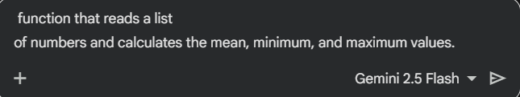
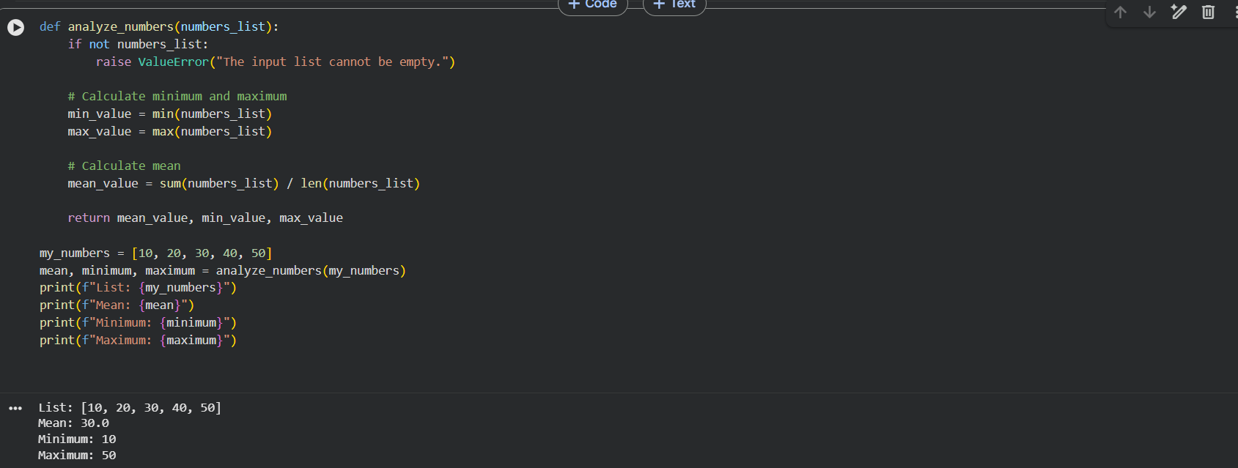

Task 2: 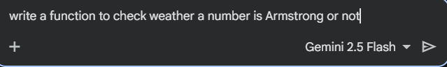
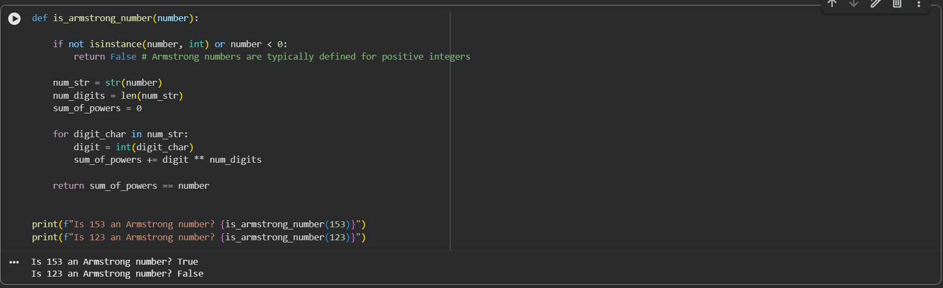
Task 3: 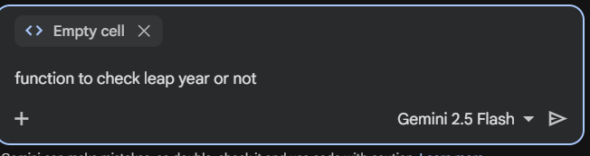
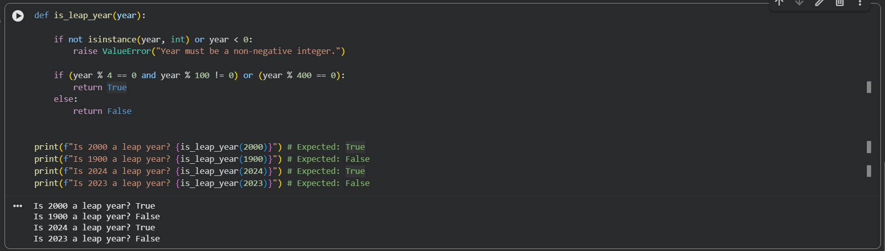
Task 4:
Original code
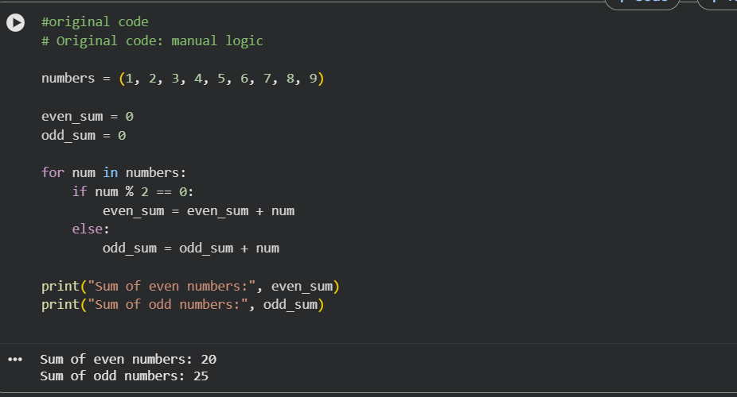
Refracted code
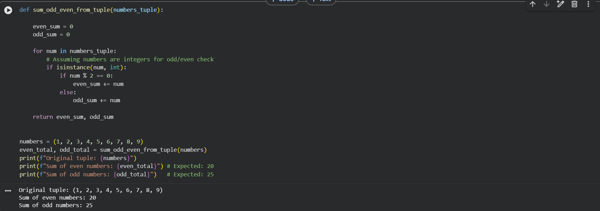
1️⃣ Code Reusability
- Original: Logic is written inline and cannot be reused easily.
- Refactored: Wrapped inside a function (sum_even_odd) → reusable and testable.
2️⃣ Readability & Maintainability
- Original: Uses a loop with manual accumulation.
- Refactored: Uses generator expressions with sum() → shorter and clearer.
3️⃣ Pythonic Style
- Original: Procedural and verbose.
- Refactored: Follows Python best practices (functional style, clean structure).
4️⃣ Separation of Concerns
- Original: Calculation and printing mixed together.
- Refactored: Calculation logic separated from output handling.

